
LKAT2 EMC

Bi-Directional High Current

Measurement with Rectifier Protection

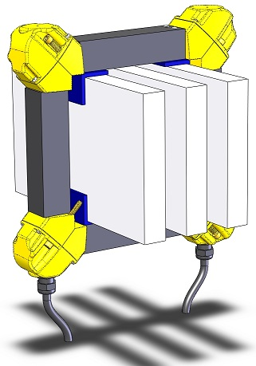

Description

The new LKAT2 combines accurate high current measurement with reverse and/or overcurrent protection in a single rugged and cost effective system.

LKAT2 offers a new level of accuracy and stability to accurately and reliably measure uni- and bi-directional DC as well as AC bus currents. The LKAT2 represents the next generation of DynAmp’s well proven OLOPTM technology.

The LKAT2 consists of a new, ruggedized two-piece measuring head with integrated mounting hardware. The Head is connected to metering electronics via two cables, one per head half. Head, cables and electronics are all rated IP65.

Application

The LKAT2 is particularly well suited to measure power rectifier outputs for control and protection purposes in electro-chemical processes such aluminum, chlor/alkali, copper, manganese, titanium, zinc, electroplating, etc.

Head, cables, cable connections and Metering Electronics are all suitable for installation in exposed locations thanks to their IP65 environmental rating.

Key Features
- True bi-directional performance. Ideal for difficult magnetic applications. No position or bus analysis needed.
- Standard alarm relay provides reverse or over-current protection.
- Measurement head and cables and Metering Electronics are rated IP65 for installation in most any environment.
- Extremely compact Metering Electronics for mounting in most any location.
- Standard Accuracy Diagnostics monitors system performance.
- Optional “Protection Extensions” can provide a second, fully isolated and independently scaled measurement output signal, plus two additional alarm relays. This allows one system to have 2 analog measurement outputs plus 3 current level alarm relay outputs plus 1 Accuracy Diagnostics alarm relay output.
- Optional 3.5 digit digital display of measured current can be viewed on the top of the metering electronics. Display can be DC or RMS AC.
- Optional low voltage DC mains allows system to be powered by safety mains supplies or even batteries.

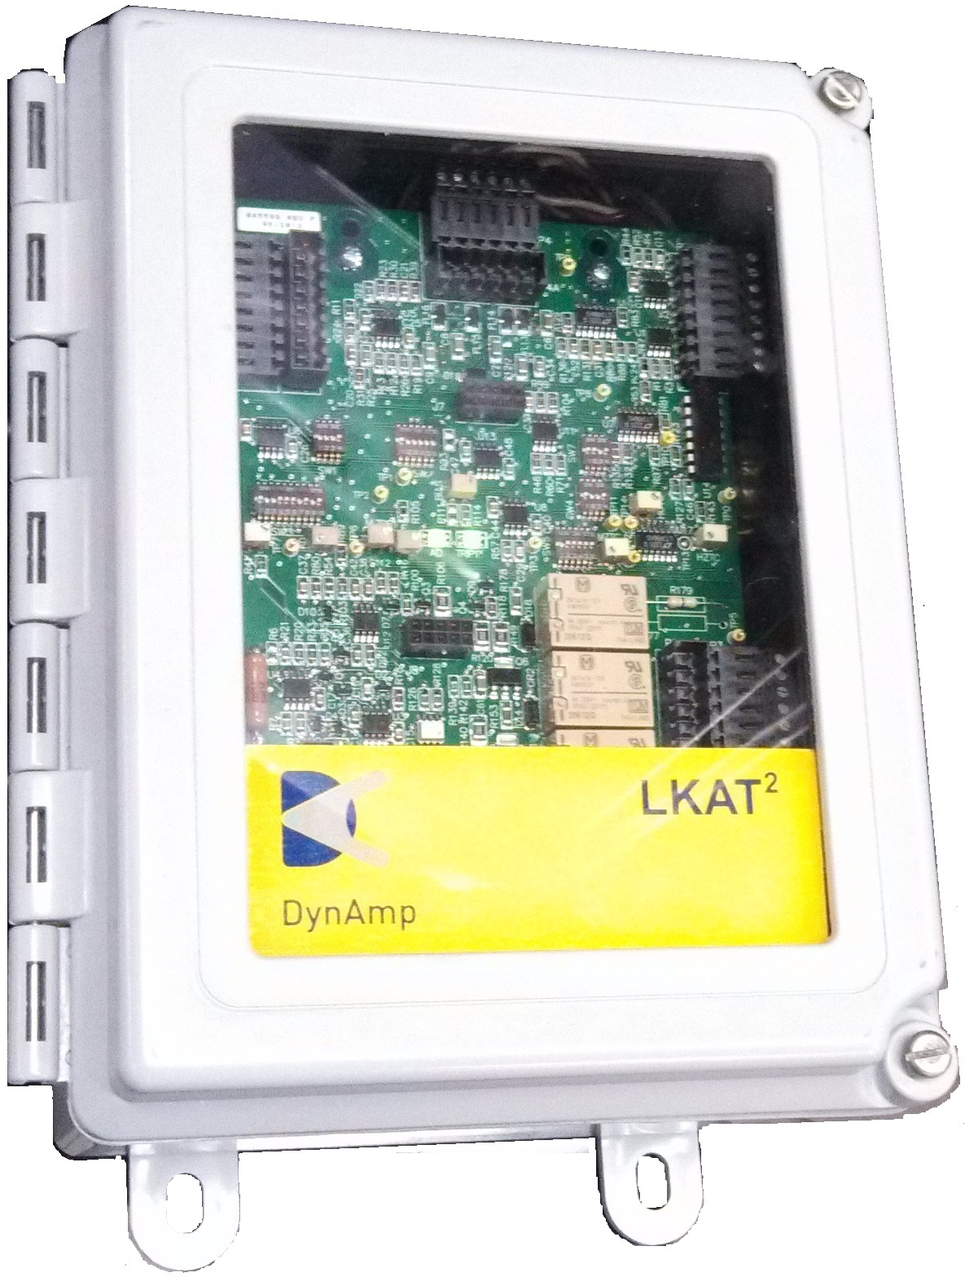

Standard System Includes

- Measurement Head : Consists of two halves with bus bar positioning hardware and bus bar mounted corner angles
- Measurement Head to Electronics connecting cables
One cable end is fixed to each head half,
Other cable end has IP65 rated connector for
connection to metering electronics
- Metering Electronics : Panel / cabinet / wall mountable
- One configurable Protection Relay with LED indication
- One Accuracy Diagnostics Relay with LED indication
- Mains and signal connection cables, with IP65 rated connectors at metering electronics for
Current measurement output signal(s)
Protection relay contacts
Accuracy Diagnostic relay contacts
Mains power input
- IP65 rated connectors for Head cables at metering electronics
- Operator / installation manual
- Calibration result data tables and graphs
- 2 year warranty
- Packaging for air transport

System Options

- Protection Extensions
Optional LKAT2 “Protection Extensions”, (PE), provides additional functionality for protecting high current rectifiers.
Second Freely Scalable Analog Output : This second analog output is independently scaled and fully isolated from the standard LKAT2 measurement output. In typical applications, it is scaled to provide accurate measurement above the rectifier standard operating range for advanced protection purposes. Using a 50kA application for example, the primary LKAT2 output may be scaled to 50kA to provide the highest degree of accuracy and resolution for normal rectifier control. The second output may be scaled to 75kA to provide the information to intelligently manage overcurrent situations. Using this signal, the rectifier control system could integrate overcurrent operation to allow 5 minutes at 110%, 1 minute at 120%, 10 sec at 140%.
Two Additional Protection Relays : These relays bring total number of configurable relays to three. Each can be configured to provide reverse or various degrees of overcurrent protection

Specify on LKAT System Worksheet BEN093

- Display and RMS conversion
Displays bus current on a 3.5 digit digital display behind the clear meter unit front panel. The option also includes an RMS converter to provide current display in AC measurement applications. NOTE: This option reduces electronics maximum ambient temperature from 60ºC to 50ºC

Specify on LKAT System Worksheet BEN093

- Custom Head Cable Length
Systems are supplied with standard 10 meter (33 ft.) of interconnecting cable between each head half and metering electronics. Other cable lengths are available in 1m increments

Specify on LKAT System Worksheet BEN093

- Custom Signal Output Cable Length
Systems are supplied with standard 30 meter (99 ft.) cable containing analog signals and relay contact connections. Other cable lengths are available in 1m increments

Specify on LKAT System Worksheet BEN093

- Custom Power Input Cable Length
Systems are supplied with standard 10 meter (33 ft.) cable for external power connection. Other cable lengths are available in 1m increments. Specify total length required when ordering.

Specify on LKAT System Worksheet BEN093

Accessories

- Summing multiple systems :
A dedicated external module is available for totalizing/ summing up to 10 LKAT measurement signals. This is typically used to provide a true ‘total’ current signal when multiple rectifiers are used in parallel.

Specify on LKAT System Worksheet BEN093

- Functional Tester :
Hand-held test set allows users to verify system operation and scaling as well as test relay trip points and output signals. See Datasheet D_LKAT_MUT for details.

Specify Item 46985

- Extended Burn-In :
Standard systems are operated for 4 hours before final tests and calibration. Extended burn-in periods can be ordered in 24-hour increments.

Specify on LKAT System Worksheet BEN093

- Extended Warranty :
Standard 2-year Warranty can be extended in 2-year increments

Specify Item 99981

Support Services

On-Site Commissioning : Factory trained technicians and specialized equipment on-site to verify correct operation in application during start-up.

Contact DynAmp

Annual / Bi-Annual Calibration : Experienced field service technicians and specially calibrated equipment are available to verify proper operation and calibrate your system to internationally traceable standards.

Contact DynAmp

Ordering Information

Complete the LKAT System Worksheet BEN093

and submit to DynAmp for quotation and ordering information.

( download from www.DynAmp.com on LKAT product page )

Measuring Head Dimensions

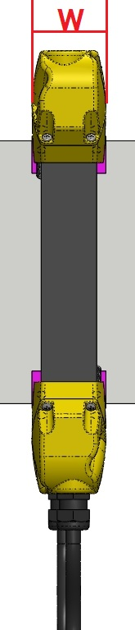
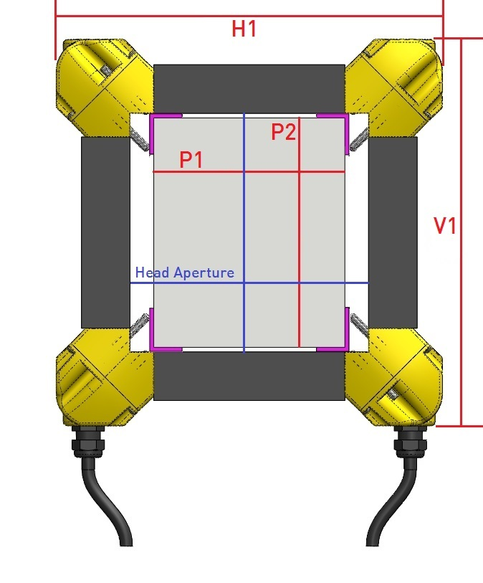
DIMENSION
Bus Size P1 & P2 | Nominal head dimensions start at 60mm (fits < 60mm bus) and increases in 30mm steps
 | ( Minimum bus dimension for standard mounting hardware is 30mm )
H1 & V1 | Nominal ‘outside’ dimension size = P1 or P2 +130mm ( 190mm minimum )
W | 60mm

Head Installation : One head is 2 head halves are joined around the bus bar and locked together via set screws
Complete head is held in position on bus bar using 8 positioning screws ( 2 at each corner )
Positioning screws are adjusted inward to contact 4 bus corner angles ( included )

Head Notes : LKAT2 measurement heads are sized per order in 30mm increments.

Actual LKAT2 head aperture is approximately the nominal head size (60mm min.+X*30mm ) plus 10mm.

For accurate sizing, provide DynAmp with actual bus dimensions via product worksheet.

Metering Electronics Dimensions

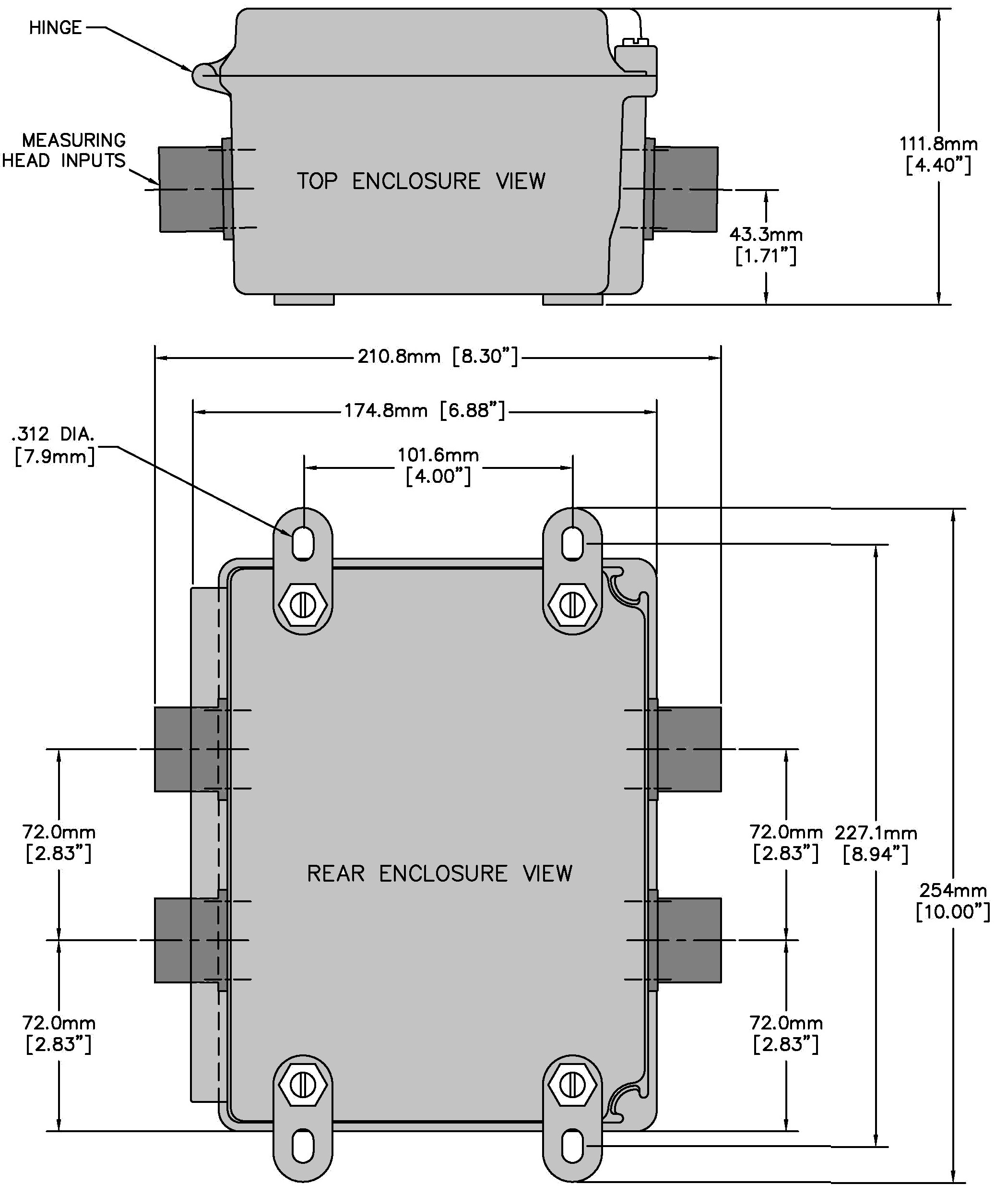

Specifications

MAIN ANALOG SIGNAL OUTPUT
Main Output Full-Scale Measuring Range | ±5kA to ±150kA ( Contact factory for full-scale measuring ranges > 150kA )
Signal Output Type (configurable)  mA output max. burden : 10V  mA output max. loop/load resistance : 500Ω  V output min. load resistance : 100kΩ | Zero kA ± Full-scale kA  0mA ±20mA max.  4mA +20 & -12mA  0V ±1V  0.2V -0.6V to +1V  0V ±10V  2V -6V to +10V
Signal Output Calibration Accuracy * | ±0.25% full-scale
Linearity Error * | ±0.1% of full-scale
Repeatability Error Limits * | ±0.1% of full-scale
Response Time (t_{d}) * | ≤ 50 μs
di/dt Accurately Followed * | 500 A/μs
Frequency Response * | Switch selectable low-pass filter :  No filter(default setting) / 330hz / 660hz  (refer to Figure 3.1 for additional info.)
Temperature Sensitivity | ±50ppm/°C or better
Mains Voltage Sensitivity | ±0.001%/V
* At DynAmp reference conditions : Ambient 25°C ± 2°C (77°F ± 4°F) / Mains 120/240V AC RMS, 60Hz ± 1Hz
MAIN STATUS INDICATORS
Accuracy Diagnostics | Indicates LKAT2 System proper operation or operational problem
Accuracy Diagnostics Status LEDs | Green LED indicates proper operation  Red LED indicates operational problem
Accuracy Diagnostics Status Relay Function | Relay coil de-energizes when operational problem detected or mains power lost.
Over / Reverse Current Trip Setpoint Qty. (1) | Factory/field configurable to trip on either over current (+5…+100% of full-scale) or reverse current (-5%...-100% of full-scale).  Setpoint accuracy ±2%
Over / Reverse Current Status LEDs | Green indicates operation OK – No Trip  Red indicates measured current exceeds Trip Setpoint
Over / Reverse Current Status Relay | Relay coil de-energizes when measured current exceeds Trip Setpoint or mains power lost.
All Relay Function | Form C : Normally Open and Normally Closed Contacts ( non-latching )
All Relay Contact Ratings | 120/250 VAC : 2A 30 VDC : 2A  Relay response time 10mS typical

OPTIONAL PROTECTION EXTENSIONS ( PE )
PE Full Scale Measuring Range (scaled independently and isolated from main output) | ±5kA to ±200kA ( Contact factory for full-scale measuring ranges > 150kA )
PE analog output configuration and performance specifications | Same as Main output above with all configuration and scaling independent from main output
PE Over / Reverse Current Trip Setpoints -Qty. (2) - Field configurable | Function and specification same as Main Over / Reverse above with independent LEDs, configurations, scalings and outputs
OPTIONAL DISPLAY
Digital Display of Bus Current in kA units | 3 ½ Digit Green LCD ±2% Full-scale
Displayed Value (configurable) | DC or True RMS
NOTE: Optional display reduces maximum ambient temperature of metering unit to 50°C
GENERAL
Input Power (any voltage within the specified range can be connected without any wiring changes) | 100 to 240Vac 50/60Hz / 120 to 264Vdc. (18 to 36Vdc optional)
Burden on Mains (max) | 30 VA
Working Voltage: Signal Output to Metering Unit Low Voltage Circuit | 450Vrms
Working Voltage: Bus to Metering Unit Low Voltage Circuit | 1500Vdc
Working Voltage: Mains Supply to Metering Unit Low Voltage Circuit | 264Vrms
Working Voltage: Mains Supply to chassis | 264Vrms
Working Voltage: Output to chassis | 450Vrms
Isolation : Head surface to signal outputs | 6000Vrms for 1 minute
Isolation : Mains supply to signal outputs | 1000Vrms for 1 minute
Isolation : Mains or signal output to chassis | 2000Vrms for 1minute
Installation Category | II
Pollution Degree | 2
ENVIRONMENTAL
Operating Ambient Temperature Range of Metering Unit Location | -10°C to 60°C  (14°F to 140°F)
Operating Ambient Temperature Range of Measuring Head | -20°C to 80°C  (-4°F to 176°F)
Environmental rating: Measuring Head and cable connection at Head | IP65
Environmental rating: Metering Unit and cable connection at Metering Unit | IP65

PHYSICAL
Measuring Head Weight | Typically 1 to 6 kg (3 to 13lbs.)
Metering Unit Weight | Typically 3kg (6.5lbs.)
Standard Length Head Connection Cables (1 cable per head half). Optional custom lengths may be available up to 50m (164 ft.) | 10m (33 ft.)  Cable fixed to Measuring Head, IP65 connector at metering electronics.
Signal Output Cable | 30m (100 ft.)  IP65 connector at metering electronics. Individual conductors at customer connection.
Power Input Cable | 10m (33 ft.)  IP65 connector connection to metering electronics. Individual conductors for customer connection.

Figure 3.1
LKAT2 Frequency Response without internal low-pass filters switched into circuit
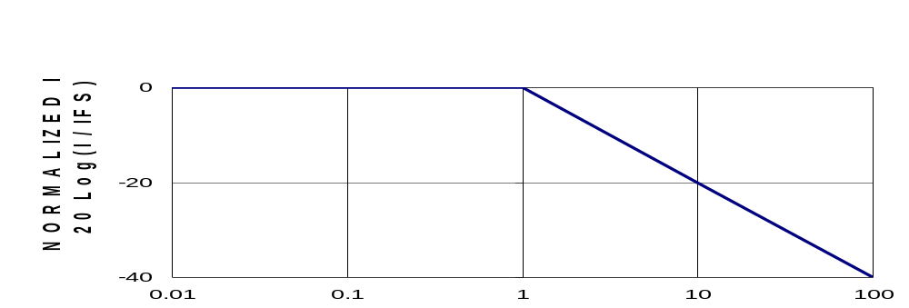
Normalized LKAT2 Bandwidth
Normalized Frequency f/fc ; fc = 1 1 2 .4 x 106 ( A / s ) / I F S ( A )

F.S. Bus Current (kA) | 5 to 50 | 60 | 70 | 80 | 90 | 100
Corner Frequency (kHz) | 2.248 | 1.873 | 1.606 | 1.405 | 1.249 | 1.124

