
LKAT2 Portable

High Current, Portable, Multi-size Head

AC / DC Current Measurement System

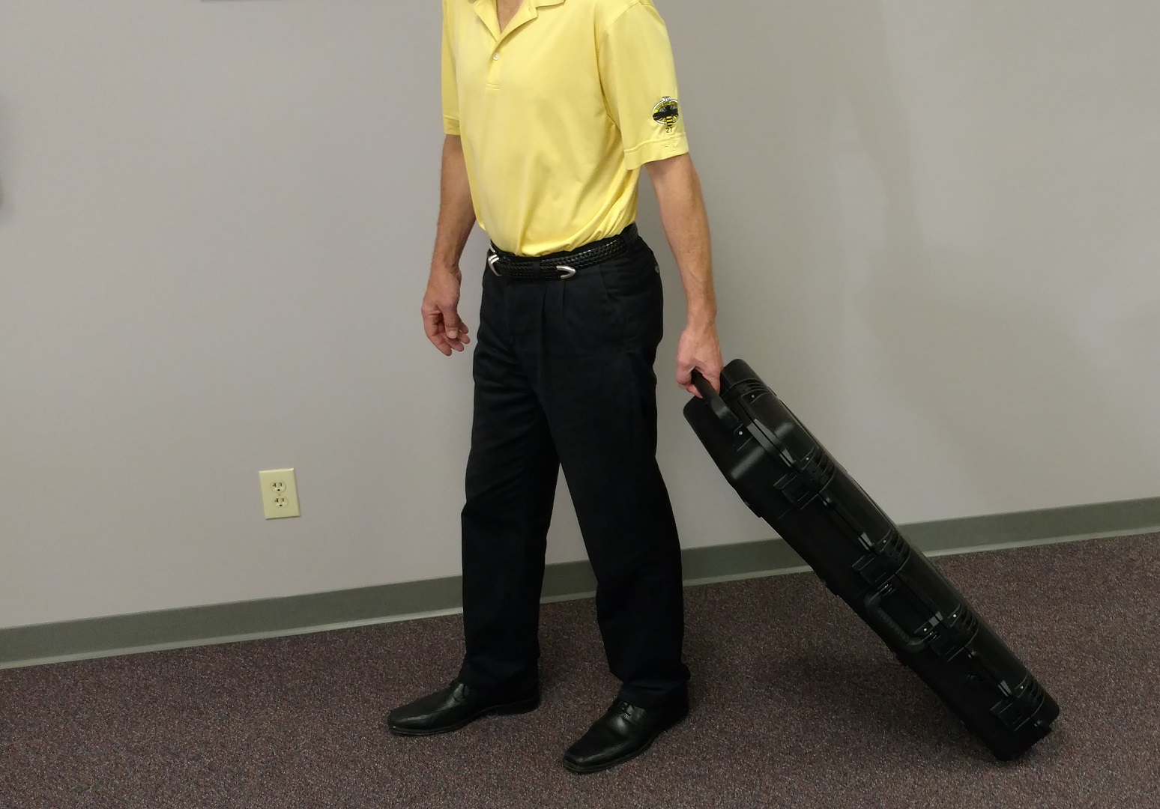

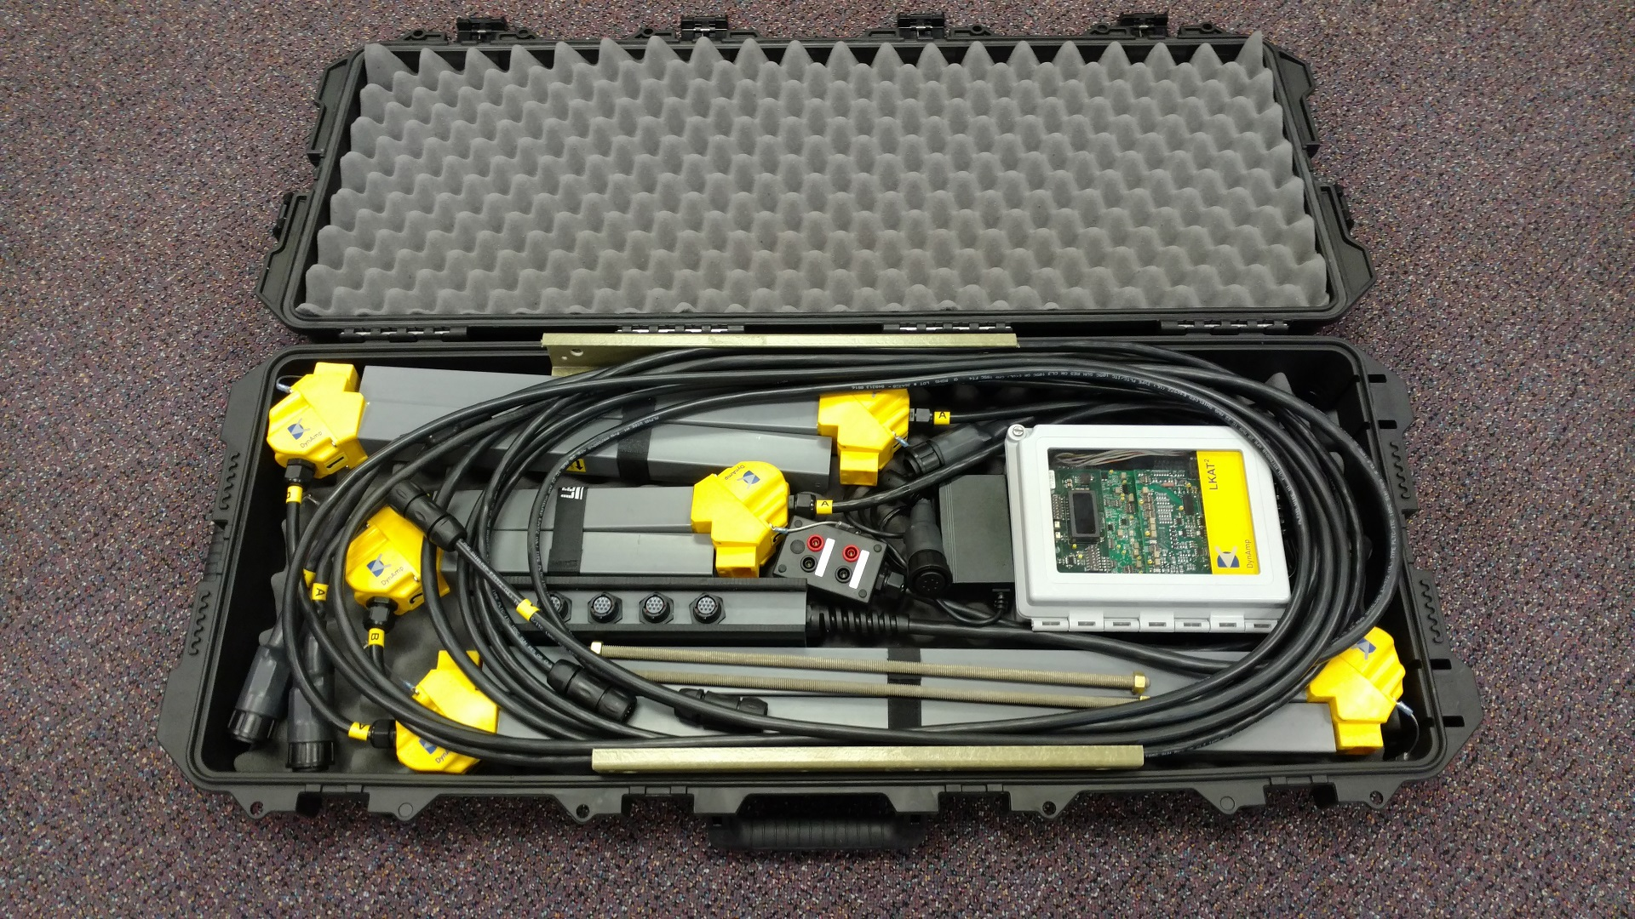

Description

DynAmp’s new LKAT2 Portable is a lightweight, extremely rugged and easy to use AC / DC measurement system for currents up to 150kA. Based on DynAmp’s well-proven 3rd Generation OLOP technology, primary measurement accuracy is 0.25%

The typical system is offered with a variety of Head ‘Sides’ enabling one system to measure almost any current on a wide variety of bus bar sizes.

System power is 18…36VDC supplied by the included mains power adapter or optionally, an external DC source such as plant safety supply or even battery.

All standard components are delivered in an easily handled hard side carrying case that meets standard airline luggage size and weight limits. No oversize or weight baggage fees.

Application Examples

- Verify current efficiency of power conversion systems and electrolysis processes such as Chlor / Alkali.
- Determine current balance / distribution in parallel bus-work.
e.g. One DC source supplying multiple electrolyzers.
e.g. Parallel bus bars / risers between aluminium pots
- Measure AC current and balance of rectifier transformer secondaries where currents are too high for ACCTs
- Check accuracy of transformer ACCTs
- Identify DC currents that may be flowing in AC systems.

Key Features
- System is compact, light-weight, rugged and easy-to-use
- Industry standard output signals for user instrumentation.
- Optional second, fully isolated and independently scaled analog output signal. For example, the main output can be scaled for 20kA with a ‘dead’ zero (0 amps = 0mA) while the second analog output can be scaled for 100kA with a live zero for process control purposes ( 0 amps = 4mA ). Both measurement signals can be converted to voltage signals via plug on adapters.
- When assembled, Head Sides, interconnection cables and all Metering Unit connections are IP65 rated.
- Low voltage DC operation allows system to be powered by included mains power adapter, safety mains supplies or even batteries.

Standard System Includes

- 4 or 6 Measuring Head Sides with connection cables
( 4 Sides assemble to one complete Measuring Head )
- Specially designed bus bar mounting brackets for temporary installation of Measuring Head on both running/horizontal and vertical/rising bus bars
- Inter-connection cable (ITC) accepts 4 Head Side cables on one end, and connects to Metering Unit on the other end.
- Metering Unit with
One analog output signal
One configurable current level alarm with LED indication
One Accuracy Diagnostics Alarm with LED indication
- Mains power adaptor with EU and US/Japan cords.
- Instrumentation signal output cable with banana jacks for connection to user’s measurement instrumentation.
- Plug-on adaptors to convert mA measurement signal to a variety of voltage signals for user’s instrumentation.
- 1 year warranty
- Hard Side Carrying Case

- Straight Head ‘Sides’ are compact, easy to pack and allow measurement of multiple bus bar sizes. Standard configuration includes 3 pairs of Head Sides.
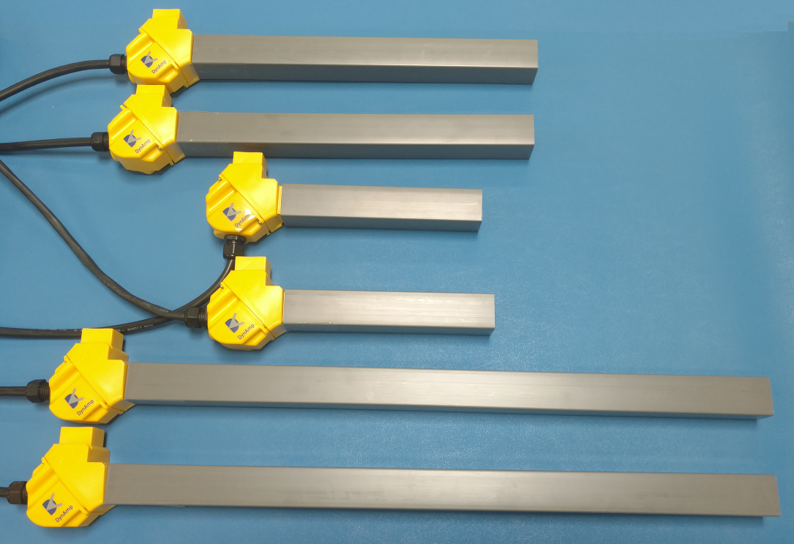

- The cables from an assembled Measuring Head ( 4 Head Sides ) connect to 1 interconnection (ITC) cable for signal transmission to the Metering Unit.
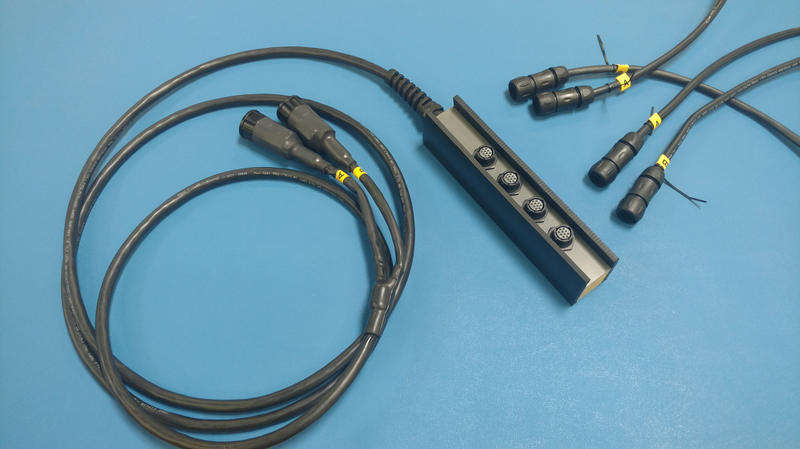

- The Metering Unit is powered by 18…36V from the included universal power adapter or an external DC supply. Even battery.
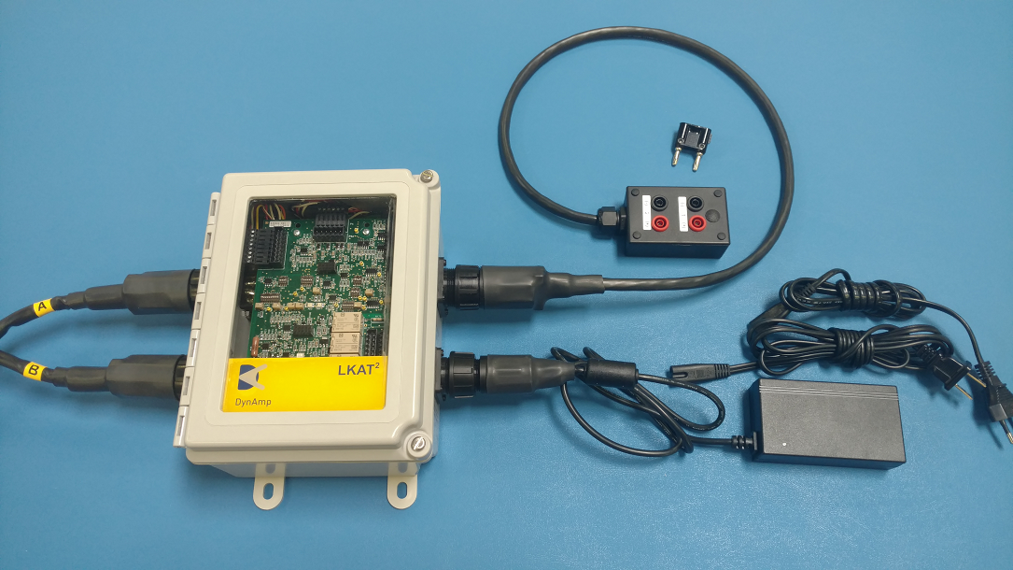

- Industry standard measurement signal output is easily changed from mA to a variety of voltage signals using included plug-on adapters.
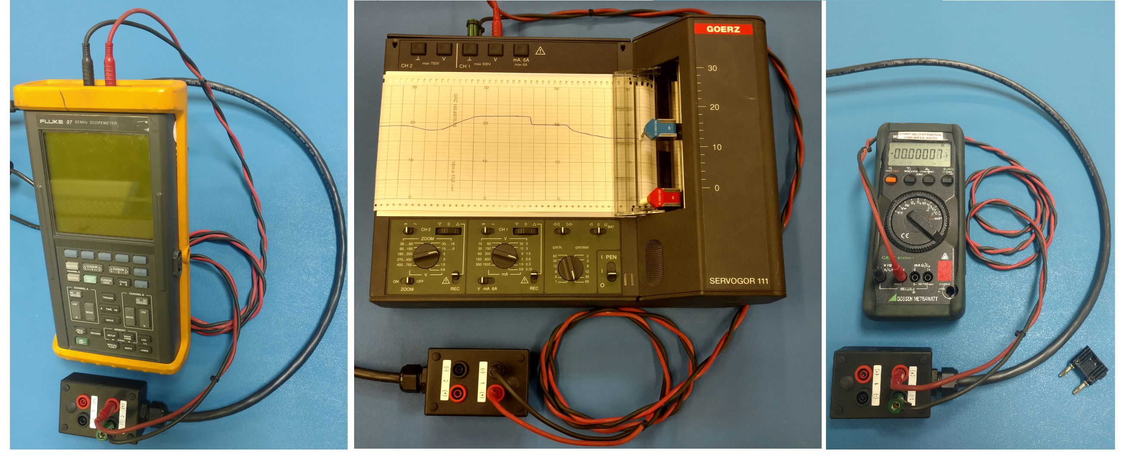
This allows simple banana jack connection to standard digital multi-meters, oscilloscopes, recorders / dataloggers, or process control system analog inputs.

Options

- Protection Extensions ( PE )
PE adds a second, fully isolated analog output which is independently configured and scaled. This allows one system to have two measurement ranges.
PE also adds 2 additional alarms for a total of 3. Each can be configured to visually signal reverse or various current levels.

- Low Accuracy Internal Display with RMS conversion
Displays bus current on a 3.5 digit digital display behind the clear Metering Unit front door. The option also includes an RMS converter to provide current display in AC measurement applications.
NOTE: This option changes Metering Unit maximum ambient temperature from 60ºC to 50ºC

Accessories

- Extended ITC Cable
Systems are supplied with standard # meter (## ft.) interconnecting cable between Head Sides and Metering Unit. Custom cable lengths are available in 1m increments.

- Process Signal Output Cable
Used in place of standard banana jack terminated cable. Allows easier connection to process control systems for longer term use.
Also provides connections to system relay contacts.

- Process Power Supply Cable
Used in place of standard power adapter. Allows direct connection to external DC supply.
- LKAT2 Functional Tester
Hand-held test set allows users to verify system operation, scaling and output signals as well as test / change alarm points. See Datasheet D_LKAT_MUT for details. This adds significant confidence in measurement performance after transportation
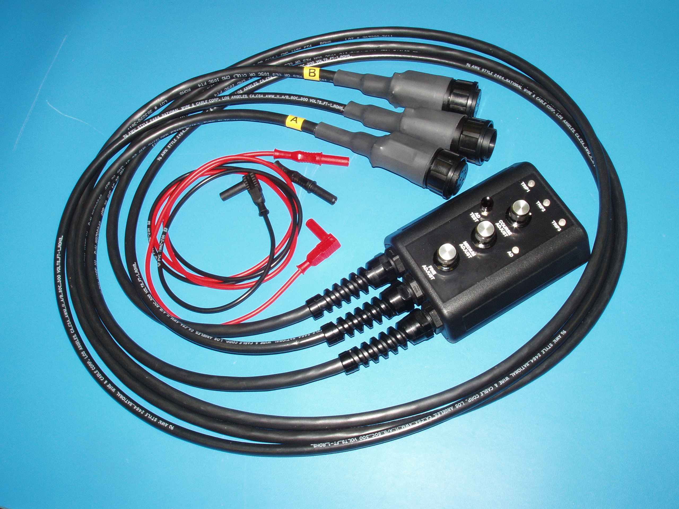

- Accessory Carry Bag

Soft Sided ‘bag’ for transport of accessories

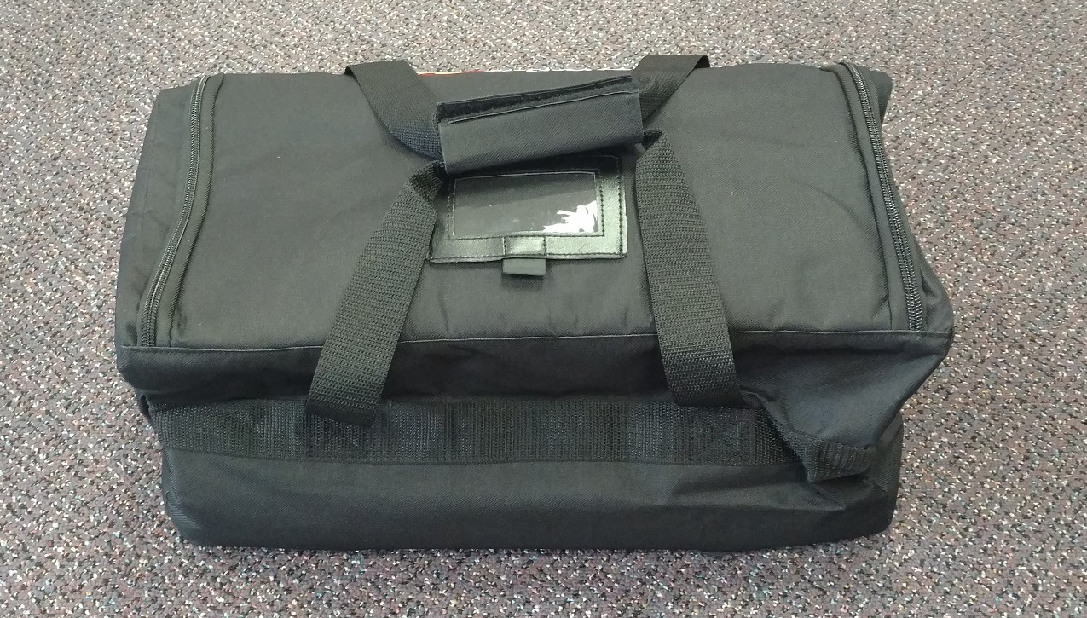

Ordering Information

Complete the LKAT2 Portable System Worksheet

(available soon at www.DynAmp.com on LKAT page)

Submit to DynAmp for offer / quotation and system item numbers for ordering.

For RUSH requirements, DynAmp stocks some standard LKAT2 Portable configurations for quick ship.

Contact DynAmp for additional details.

Head Side Pair Head Width

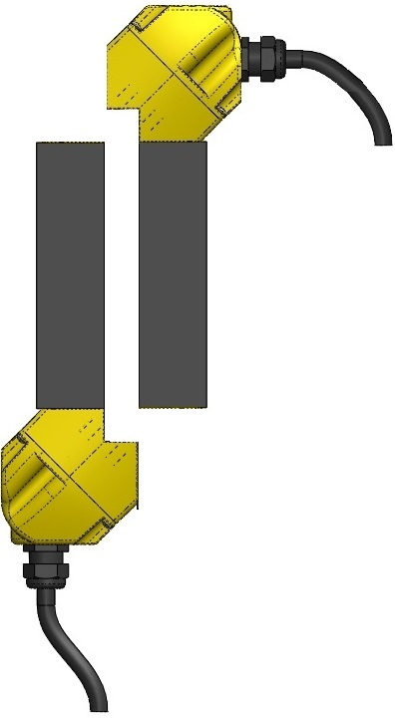

Head Side sizes start at 60mm (to fit either a P1 or P2 bus dimension of < 60mm) and increase in 30mm steps

Assembled Measuring Head
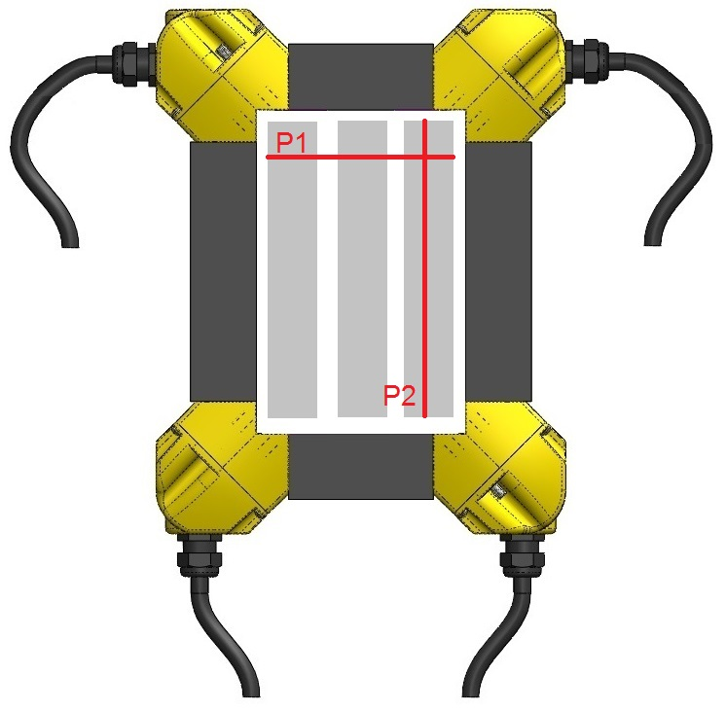

Specifications ______________

MAIN ANALOG SIGNAL OUTPUT
Main Output Full-Scale Measuring Range | ±5kA to ±150kA ( Contact factory for full-scale Measuring ranges > 100kA )
Signal Output Type (configurable)  mA output max. burden : 10V  max. loop/load resistance : 500Ω  V output : via plug-on converters | Zero kA ± Full-scale kA  0mA ±20mA max.  4mA +20 & -12mA  20mA converted to 1, 2, 5, 10 Volts
Signal Output Calibration Accuracy *  Head Side Pairs 1 and 2  Head Side Pairs 1 and 3  Head Side Pairs 2 and 3 | ±0.25% full-scale  ±0.50% full-scale  Not specified : typical ±0.75% full-scale
Linearity Error * | ±0.1% of full-scale
Repeatability Error Limits * | ±0.1% of full-scale
Response Time (t_{d}) * | ≤ 50 μs
di/dt Accurately Followed * | 500 A/μs
Frequency Response * | Switch selectable low-pass filter :  No filter / 330hz / 660hz  (refer to Figure 3.1 for additional info.)
Temperature Sensitivity | ±50ppm/°C or better
Mains Voltage Sensitivity | ±0.001%/V
* At DynAmp reference conditions : Ambient 25°C ± 2°C (77°F ± 4°F) / Mains 120/240V AC RMS, 60Hz ± 1Hz
MAIN STATUS INDICATORS
Accuracy Diagnostics  Accuracy Diagnostics Status LEDs  Accuracy Diagnostics Status Relay  (Relay contacts only available via optional process cable) | Monitors system function  Green LED indicates proper operation  Red LED indicates operational problem  Relay coil de-energizes when operational problem detected or mains power lost.
Over / Reverse Current Trip Setpoint  ( Factory and Field configurable )  Over / Reverse Current Status LEDs  Over / Reverse Current Status Relay  (Relay contacts only available via optional process cable) | Configurable to trip on either  over current (+5…+100% of full-scale) or reverse current (-5%...-100% of full-scale).  Setpoint accuracy ±2%  Green indicates operation OK – No Trip  Red indicates measured current exceeds Trip Setpoint  Relay coil de-energizes when measured current exceeds Setpoint or mains power lost.
All Relay Functions  (Relay contacts only available via optional process cable) | Form C : Normally Open and Normally Closed Contacts ( non-latching )
All Relay Contact Ratings  (Relay contacts only available via optional process cable) | 120/250 VAC : 8A 30 VDC : 8A  Relay response time 10mS typical

OPTION : PROTECTION EXTENSIONS ( PE )
PE Full Scale Measuring Range  (scaled independently and isolated from main output) | ±5kA to ±200kA  ( Contact factory for Measuring ranges > 100kA )
PE analog output configuration and specifications | Same as Main output above with all scaling and configuration independent from Main output
PE Over / Reverse Current Trip Setpoints – Qty(2) ( Factory and Field Configurable )  (Relay contacts only available via optional process cable) | 2 independent Setpoints, 2 independent LEDs and 2 independent relays.  Function and specification same as Main Over / Reverse function above
OPTION : LOW ACCURACY INTERNAL DIGITAL DISPLAY
Digital Display of Bus Current in kA units | 3 ½ Digit Green LCD ( ± 2.0 % Full-scale )
Displayed Value (configurable) | DC or True RMS
NOTE: Optional display reduces maximum ambient temperature of Metering Unit to 50°C
GENERAL
Input Power  (any voltage within the specified range can be connected without any wiring changes) | 18 to 36Vdc.  Included Adaptor for 100…240VAC 50…60Hz. (US / Japan and EU mains power cords included )  Optional Rechargeable battery pack ( future )
Power Consumption (max) | < 30VA
Working Voltages:  Signal Out to Metering Unit Low Voltage Circuit  Bus to Metering Unit Low Voltage Circuit | 450Vrms  1500Vdc
Isolation :  Measuring Head surface to signal outputs  Mains supply to signal outputs  Mains or signal output to chassis | 6000Vrms for 1 minute  1000Vrms for 1 minute  2000Vrms for 1minute
Installation Category | III
Pollution Degree | 2
ENVIRONMENTAL
Operating Ambient Temperature Range of Metering Unit | -10°C to 60°C  (14°F to 140°F)
Operating Ambient Temperature Range of Measuring Head | -20°C to 80°C  (-4°F to 176°F)
All Connections at Head and Metering Unit  Mains Power connectors at Mains Power adapter  Signal output cable at banana jack connection | IP65 rating after connectors mated  IP 22 rating  IP 22 rating

PHYSICAL
Assembled Measuring Head (4 Sides ) | Typically 1 to 6 kg (3 to 13lbs.)
Head Side Cables (4, 1 per Side) | 2m (6.7 ft.) : Fixed to Head Side. Connector for ITC Cable on opposite end
1pc Interconnection Cable (ITC)  Optional custom lengths are available | 5m (16 ft.) : 4 Head Side Cables connect at one end, 2 connectors for Metering Unit on opposite end
Metering Unit | 211 x 254 x 112mm, Typically 4kg
Instrument Output Cable  Optional : Process Output Cable | 2.5m (8.2 ft.) : Custom lengths available  Measurement signal(s) only, no relay connections  Connector for Metering Unit on one end,  banana jacks for signal output(s) on opposite end  10m (33 ft.) : Custom lengths available  Measurement signal(s) and relay connections  Connector for Metering Unit on one end, unterminated wires on opposite end
Mains Power Adapter Cable / Set  Optional : Process Mains Cable | 2m (6.6 ft.) : custom lengths are available  Metering Unit connector on one end, plug-on mains power cord on opposite end ( USA and EUR mains power cable supplied, others available on request )  For direct connection to low voltage mains
Carrying / Transport Cases | Hard side carrying case included  (additional soft side case with optional assemblies )

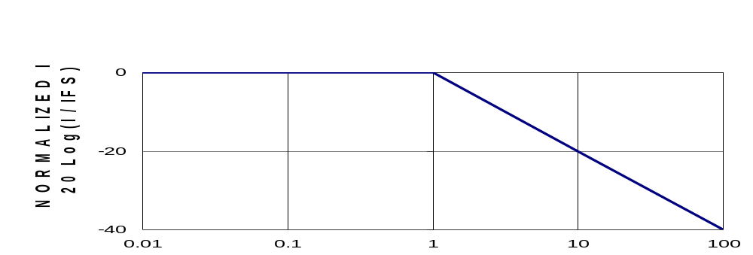
LKAT2p Frequency Response without internal low-pass filters switched into circuit

Normalized LKAT2p Bandwidth

Normalized Frequency f/fc ; fc = 1 1 2 .4 x 106 ( A / s ) / I F S ( A )

F.S. Bus Current (kA) | 5 to 50 | 60 | 70 | 80 | 90 | 100
Corner Frequency (kHz) | 2.248 | 1.873 | 1.606 | 1.405 | 1.249 | 1.124

